The Young Clergy Initiative
Grant Application 2020

The purpose of the Young Clergy Initiative is to increase the number of young clergy in The United Methodist Church by helping youth and young adults discern whether their call to ministry is a call to ordained or licensed ministry.

Thank you for your interest in pursuing the purpose of the Young Clergy Initiative.

If you have requested YCI funds in previous years, we have simplified this grant application to make requesting funds easier. There is no online application platform this year. Type your response to the application questions underneath the respective question and save (because that’s what Jesus would do).

When you are ready to submit your application, email yci@gbhem.org a version of your:
- Application (Word or PDF)
- Project’s budget (Excel or PDF)

You will receive a confirmation email from us after we have read over your application and made sure all the components are completed. Applications will be reviewed for awarding in April. Award notifications will be made by May 15.

Email us at yci@gbhem.org with any of your YCI questions.

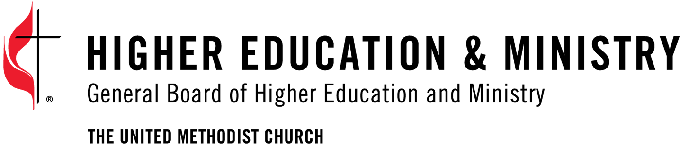

Project’s working title:
(Adjustments are allowed as your project unfolds.)

How much funding (USD) are you requesting from the YCI?

Project manager’s name:
(This is the person who will be contacting regarding the project.)

Project manager’s email:
(This will be our primary mode of contact regarding the project.)

Annual Conference affiliation:
(You project may have connections with multiple Conferences. Please identify one as the primary Conference.)

Jurisdiction affiliation:
(Your project may have connections with multiple Jurisdictions. Please identify one as the primary Jurisdiction.)

Project category:
(Choose the category that best describes the experience your project is providing.)

- Call Exploration Event –a short-term, retreat opportunity for participants to engage speakers, attend in workshops and/or panel discussions, or participate in group conversations.
- Educational Experience – a longer-term opportunity for participants to engage facilitators and other participants while studying vocational ministry. These projects might be offered through an academic setting at various levels.
- Missional Experience – a short-term missional opportunity for participants to engage those in need to discern a call to vocational ministry.
- Internship Experience – a short or long-term opportunity for participants to experience vocational ministry in a hands-on fashion.
- Small Group Experience – a long-term opportunity for participants to engage facilitators and other participants while processing a call to vocational ministry.

How does your project fulfill the purpose of the YCI as stated in the General Conference legislation?
(This is your project’s “elevator speech”. Keep your response under 200 words.)

Who are you in partnership with related to your project?
(e.g., Annual Conference, seminary, educational institution, local church, Wesley Foundation, community organization)

What are three (3) measurable, short-term goals for your project?
(e.g., (1) participation of 50 students by August 1, (2) 10 churches commit to accepting interns by September 3rd, (3) 5 small groups of 5 participants formed by November 4.)

Describe the work of your project.
(This is your opportunity to go into more detail and brag about your project.)

What is your project’s timeline?
(Adjustments are allowed as your project unfolds.)

What is the expected duration of your project?
(The YCI can only commit funds for 1 year. You must reapply annually for YCI funding.)

- 1 year
- 2 years
- 3 years
- 4 years

Include your project’s budget with the application.
(In addition to other relevant line items in your budget, make sure to identify: (1) other sources of non-YCI income and (2) how much funding is being used for salary support.)

Your budget MUST BE attached in the same email you attach your application.

How do you plan to fund this project’s work beyond the timeframe of the YCI funding period?

Episcopal notification:
(Your project information should be shared with the episcopal leader (bishop) in your primary annual conference. This helps leadership stay aware of the good work being done in their area and allows them to encourage connection across episcopal areas.)

- I have made the episcopal leader of my primary annual conference aware of this funding request and the intended use of those funds.

Application Submitter’s Name:
(This is the person who has completed and submitted the project application.)

