Full Worship Resource

Contributors 2
Title Suggestions for Worship Services 3
Option #1 – Three or Four Week Series 3
Option #2 – Single Service 3
Suggestions for Using the Liturgical Resources 3
Liturgical Resources 3
Call to Worship 3
Opening Prayer 4
Congregational Litany 4
Adaptation of the Great Thanksgiving Prayer 5
Benediction 6
Poem 6
Suggestions for Using the Sermon Starters 7
Sermon Starters 8
Tracing a Call through an Asian American Story and Beyond 8
The Big Picture: Creating a Culture of Call 11
Called to the Breath of Life 14
Ministry of All Believers 16
Suggestions for Using Questions for Further Reflection 19
Questions for Further Reflection 19
Invite and Empower Witnesses 21

Contributors

Worship Resources

Rachel Billups
Executive Pastor of Discipleship
Ginghamsburg UMC
Tipp City, OH

Lisa Degrenia
Senior Pastor
Trinity UMC
Sarasota, FL

Gerald Liu
Assistant Prof. of Homiletics & Worship Arts
Drew Theological School
Madison, NJ

Eric Soard
Missionary
General Board of Global Ministries
United Republic of Tanzania

Cynthia Wilson
Dean of Students
Garrett-Evangelical Theological Seminary
Evanston, IL

Worship Resource Editors

Dawn Chesser
Director of Preaching Ministries
Discipleship Ministries
Nashville, TN

Trip Lowery
Director of Young Adult Ministry
Discernment and Enlistment
General Board of Higher Educ. and Ministry
Nashville, TN
Educational Resources

Tyler Vittetoe
High School & College Pastor
Christ UMC
Mobile, AL

Patty Smith
Director of Children’s & Family Ministries
Tennessee Annual Conference
Nashville, TN

Jeremy Steele
Next Generation Minister
Christ UMC
Mobile, AL

Educational Resource Editor

Trip Lowery
Director of Young Adult Ministry
Discernment and Enlistment
General Board of Higher Educ. and Ministry
Nashville, TN

Title Suggestions for Worship Services

Option #1 – Three or Four Week Series

Suggested Theme Titles:
- Week One: God’s Call is for ALL!
- Week Two: Is that YOU, God?
- Week Three: Are you sure you mean ME?
- Week Four: Here I am, Lord!

Option #2 – Single Service

Suggested Theme Title: Creating a Culture of Call

Suggestions for Using the Liturgical Resources

Included in the resources are suggested litanies and prayers for use in worship. If you are presenting the material over several weeks, you could create continuity from week to week by inviting the congregation to engage in the same Call to Worship and Benediction each week during the series. If you are celebrating Holy Communion be sure to check out the adaption of The Great Thanksgiving included in this resource! If you use bulletins in your congregation, consider using the poem to create your own original cover art for use during the series.

Key:
- Spoken by one
- Spoken by all
- [Action directions]

Liturgical Resources

Call to Worship

Faithful One, calling in the night

Speak, we’re listening

Still Small Voice, calling in the silence

Speak, we’re listening

Moment of silence

Opening Prayer

Praise the One, True Living God
Liberating Flame, burning away our chains
Empowering Flame, burning away our excuses

Praise the Great I AM
Forever and for always bringing
answers out of questions
preparation out of hesitation
yes out of no

Praise our Deliverer,
Who saves and summons
Calling us to new life
Calling us to new life

Congregational Litany

[One or all singing]

Lord, You Have Come to the Lakeshore (United Methodist Hymnal #344, verse 1)

[Instrumental music continues during the readings and prayer]

When Jesus saw the crowds, he had compassion for them, because they were harassed and helpless, like sheep without a shepherd. Then he said to his disciples, "The harvest is plentiful, but the laborers are few; therefore ask the Lord of the harvest to send out laborers into his harvest." (Matthew 9:36-38)

I heard the voice of the Lord saying,
"Whom shall I send, and who will go for us?"
And I said, "Here am I; send me!" (Isaiah 6:8)

[All singing]

Lord, You Have Come to the Lakeshore (United Methodist Hymnal #344, verse 2, 3)

Jesus said, “You will receive power when the Holy Spirit has come upon you; and you will be my witnesses in Jerusalem, in all Judea and Samaria, and to the ends of the earth” (Acts 1:8)

Holy Spirit, you opened my ears to hear Jesus calling me to serve
You opened my step to the path now set before me
Continue to open me
Open my mind to the changes I must make
Open my arms to the new life I will embrace
Open my hands to those I will partner with in service
Open my eyes to the resources, answers and grace you will provide
Open my mouth with your love, truth and wisdom
Open my heart and fill it again and again with the courage to follow faithfully

[All singing]

Lord, You Have Come to the Lakeshore (United Methodist Hymnal #344, verse 4)

Adaptation of the Great Thanksgiving Prayer

Blessed God
One, yet Three
Eternally loving, creating, calling

We lift up our hearts to You!

You call the wonder of creation into being
You fill the world with light and life

Glory to God! Make us your light!
Glory to God! Raise us to life!

When the fullness of time had come
You called our sister Mary
to nurture and nourish your Word Made Flesh
You called our brother John
to make way for your Glorious Good News

Open our ears and hearts to Your call

When the fullness of time had come
Your Son, our Savior,
Called one and all to
“Come and see”
“Come and follow”

Lamb of God, I come, I come

When the fullness of time had come
Jesus called his followers to table
“Come, take, eat and drink”
Giving thanks, breaking bread, raising cup
Body and Blood
Pardon and Provision
Grace upon grace

We bow in remembrance
We stand in awe
Forgive us and empower us
so we may lead lives worthy of Your calling

Come Holy Spirit,
Abide with us and in us
and on these gifts of bread and wine
Make them be for us the body and blood of Christ
that we may carry Your welcome to all people
and be useful to You in Your saving work

Holy One- Father, Son, Spirit
Your Kingdom come, Your will be done
All to the glory and honor of Your Name. Amen

Benediction

May the call of Jesus, be ever in your ears
The hope of Jesus, ever on your lips
The peace of Jesus, ever in your touch
The strength of Jesus, ever in your step
Amen

Poem

Community
by Lisa Degrenia

God lives in community
One and yet Three
Loving, creating, eternally
We’re called to community
One, yet Many
Loving, creating, one family

All praise to the Trinity
The One who is Three
Who came as a baby
To calm our rough sea
Who died on a lonely tree
And rose on day three
Loving, creating, our victory

God lives in community
With all who believe
Loving, creating,
What we’re to be
We’re called to community
For now we can see
That loving, creating,
Makes us all free

Suggestions for Using the Sermon Starters

The resource includes Sermon Starters from four individuals who have each listened for God’s voice, discerned God’s particular call on their lives, and responded in very different ways. Some may have at first been confused at first about the voice they were hearing, as Eli was when he first heard the voice of God calling him in the tent (see 1 Samuel 3:1-10). Others may have felt inadequate to respond at first, as in the case of Moses (see Exodus 3:1-12). Still others may have resisted, but God’s persistent voice presented in different ways eventually provided clarity. Every person’s experience of God’s call is different. As you read each contributor’s story, think about what enabled the writer to hear God speaking to him or her, how he or she discerned the particular place of ministry God to which he or she was being called, and how that person responded by his or her education and vocational choice. Finally, how does the writer help you to enable and empower the people in the congregation you serve to listen, discern, and respond to God’s call in their own lives?

Sermon Starters

Tracing a Call through an Asian American Story and Beyond
by Rev. Dr. Gerald C. Liu

Scripture passages for reflection:
- Ezekiel 37:1-6
- Psalm 104:24
- Acts 2:1-21
- John 16:12-25
- Romans 8:22-27

I pursued my Master of Divinity degree strictly as an intellectual exercise until I began working at a United Methodist Church in Clarkston, Georgia. Clarkston resembled something like Mayberry, the fictional small country town of the Andy Griffiths television show. A train track divided it. The Methodist church sat next door to the Baptist church. I lived in a dogtrot parsonage behind the sanctuary. Yet Clarkston wasn’t Mayberry. It was the world. Eleven different nationalities worshipped in our congregation of one hundred. Thirteen different languages were spoken at the public high school. At that time, the town was the second largest hub of refugees from Africa and many others resettled there too. Every weekday morning, women and men from Sierra Leone, Congo, Sudan, and Ethiopia but also Bosnia, Burma (Myanmar), Nepal, and Mexico would walk to English as a Second Language instruction at the Baptist church. The wonder and ministerial potential of it all compelled me to pursue ordination as an Elder in the UMC.

From there I went on to study theology in Germany and serve churches in greater Atlanta and the United Kingdom. I completed a Ph.D. and taught in Boston and Louisville before landing at Drew Theological School in Madison, New Jersey as an assistant professor of preaching and worship arts.

In Ezekiel 37:1-6 things are looking bad for the house of Israel. So much so that
Ezekiel has a vision where all he sees are dry bones. God poses the question, “Mortal, can these bones live?” Ezekiel answers, “O Lord God, you know.” God does know. God instructs Ezekiel that he must prophesy to the bones! They will take on flesh and live as a testimony that the nightmare of death cannot stop God’s promise of life for Israel.

Before professional ministry and higher education I converted to Christianity. I was 11 years old. My friend David had invited me to a Christian music concert. An orchestra named “Truth” performed and extended what we in the South would call an “altar call” after the finale. I followed. The Spirit didn’t move me. I thought, “Shoot, there goes my ride home!” A couple of weeks later another friend, Aaron, invited me to a Sunday morning service. The preacher implored, “If you died tonight, are you going to go to Heaven or Hell?” Well, I didn’t want to go to hell. So, I prayed a prayer to Jesus right then and there. When I told my mom the news, for her it was as if I was assimilating to American culture. I cried because I thought she was going to hell. Her concern was partly true. My worry had no well-reasoned basis. Only God knows our destinies (and most mothers are heaven bound). While the evangelism techniques of those musicians and that preacher worked and their motivations were good, the bite-sized theology they shared ended up drying out. It was good but insufficient, incapable of providing enough spiritual energy to work through complex conversations and questions that I had. Good seeds were planted by the concert and worship service. Yet they were rooted more in the finality of death rather than the infinite mystery and wonder of life in God. The traumatizing thoughts I had about my mother’s soul could not be compared to the dry bones of Ezekiel. For me they were in fact worse than what Ezekiel saw. But like Ezekiel I needed Divine intervention and words capable of bringing life when I could only see death. I would need more to prepare for surprising experiences like my stint in Clarkston and other unexpected twists and turns in my unfolding vocation as a pastor and theological educator.

I applied to seminary ambivalently during my senior year of college. I was a business-turned-music-major and also helped lead music for a campus Fellowship of Christian Athletes [FCA]. My friend Matt led FCA and was a year older. After graduation he went to study theology and I was curious why. Through our conversations he convinced me to apply and find out for myself. I did but without seeking financial aid. I figured God would provide if it were meant to be.

Through a series of very unlikely events, one of my applications compelled an admissions officer, Tracy, to phone and ask why I had not applied for any scholarship money at her institution. She invited me to submit a supplemental application due days ago. I was unsuccessful at first. But a student ended up declining a scholarship opportunity. I was invited to interview. Upon my return I went from taking one undergraduate course in Judaism to being awarded along with five other incoming students the highest award the institution she represented offered.

I do not associate that moment of serendipity with a “health and wealth” view of God’s working in the world. I understand that gift within the all-encompassing outlook of the Psalmist. Psalm 104:24 polyphonically sings, “O Lord, how manifold are your works! In wisdom you have made them all; the earth is full of your creatures.” The entire world as well as humanity radiates life given by God. By pulling a file and reaching out to me, Tracy was not just a creature of God. She was a messenger who connected my path to a larger tradition of faith seeking understanding.

Your sense of call may not overlap with mine. My reflection may even sound banal.

Or, maybe my story has portrayed another dimension of what a call can be. As we discern a call, it is crucial to realize each and every calling has its own mystique. The gospel of John and Paul’s letter to the Romans are helpful here. John 16:12-15 recounts Jesus describing how the “Spirit of Truth” comes as a guide to declare the mysteries of God. In other words, Jesus assures his disciples that God will make Divine mysteries clear. The disciples especially need that assurance as they face and vex over the eventual crucifixion of Jesus. That goes for us today too as we try to make sense of God’s future and our place within it. Romans 8:22-27 captures the kind of disposition we need and with some connection to Ezekiel. Hope is placed in what cannot be seen – the renewing life of God. And yet Paul also writes with vividness similar to the Psalter. The creation groans with us in longing for God’s total redemption. We squint to view God in our lives now. No matter how dim that view might be or how confused we might feel Paul trusts the words of Jesus when he assures us that the “Spirit helps us in our weakness; for we do not know how to pray as we ought, but that very Spirit intercedes with sighs too deep for words. And God, who searches the heart, knows what is the mind of the Spirit, because the Spirit intercedes for the saints according to the will of God.” The Spirit makes sense of what God desires for us.

Discerning a call requires patient and swift thoughtfulness. Callings happen in ordinary and exponential ways. When Christian congregations began, the people of God spoke languages they had never learned. They understood each other by sharing radical difference, including religious plurality – A Jewish festival transformed and “[n]ow there were devout Jews from every nation” and “Are not all these who are speaking Galileans? And how is it that we hear, each of us, in our own native language. Parthinians, Medes, Elamites, and residents of Mesopotamia, Judea and Cappadocia, Pontus and Asia, Phrygia and Pamphylia, Egypt and the parts of Libya belonging to Cyrene, and visitors from Rome, both Jews and proselytes, Cretans and Arabs -- in our own languages we hear them speaking about God's deeds of power.” People though that the multilingual and multicultural participants of Pentecost in Acts 2:5-13 were drunk.

In fact, the Spirit of God harmonized dissonant voices and identities to declare that “sons and daughters,” “young and old,” “even slaves,” “everyone who calls on the name of the Lord shall be saved” (Acts 2:21). How will we continue that exhilarating proclamation?

For further reflection:

- Write in a paragraph or two about your story or developing sense of call.
- Choose a biblical passage or passages here or elsewhere and write another paragraph or two exploring how it is that God seems to be summoning transformation and/or expressing God’s faithfulness in the Bible.
- What happens when you put your autobiographical and biblical paragraphs into conversation? What are the points of convergence and divergence? Are there unexpected realizations that broaden your understanding of what discerning a call entails?
- What questions must be asked and what horizons must be considered beyond your story and the Bible to compel continual growth in understandings of call? Articulate and respond to those questions in another paragraph or two.
- Take the paragraphs written above and compose and rehearse a sermon that portrays the Holy Spirit calling us in “real life,” in the Bible, and into futures yet unknown.

The Big Picture: Creating a Culture of Call
by Rev. Rachel Billups

Scripture passage for reflection:
- Acts 2: 17-21

“What do you want to be when you grow up?”

It’s a question that we’ve asked or has been asked of us when dreaming about our futures. Contemporary answers to this question are very different from the answers given twenty-five years ago. For starters, many people don’t anticipate having the same career, let alone job, for decades at a time. It’s nothing for millennials to change jobs, move to new cities, and even explore new careers given the right vision and opportunity. This creates what at times can feel like career chaos.

In the midst of this uncertainty, perhaps we should be asking some questions of our own, such as:

- What role does the church play in determining a person’s career path?
- Can the church help people ponder the question “What do you want to be when you grow up?”
- How are we creating a culture of call?

I believe we not only can, but should actively be creating a culture of call. How?

By gifting people with pictures!

Now, I’ve got to be honest: I grew up with limited pictures. In fact, I remember one of my first articulations of my own call into pastoral ministry. I was sitting around the kitchen table reading scripture as my mom was frying eggs for breakfast. I grew up on a small cattle farm in the hills of rural Ohio, and although I loved my childhood, my pictures of the church were limited. South Perry UMC worshiped about 50 faithful people on a good Sunday. So there I was, a forkful of eggs in hand, when I said to my mom, “I think God is calling me to be a preacher’s wife.” Thankfully, through the work of the Holy Spirit God placed incredible people in my life to give me broader visions of call.

We, the church, are designed, called, commissioned to give people picture—God-sized pictures—of what God has called and created them to do and to be. In other words, we are charged with creating a culture of call. What better day to begin creating a culture of call than Pentecost?

In Acts 2, the disciples were gathered together in the Upper Room waiting for the gift that Jesus had promised. These people weren’t merely the twelve disciples. Present also were many who had staked their claim in Jesus being the Messiah, the future King of the known world.

We can imagine the fear, the frustration, and the doubt they must have been feeling. But we can also imagine the anticipation in the room. The Bible tells us in Acts 1: 14, “They all joined together constantly in prayer, along with the women, and Mary the mother of Jesus, and with his brothers” (NIV). They weren’t just passively sitting there. They were actively waiting for what God had next! God had claimed their lives! This in and of itself is extraordinary. Why?? Because the disciples and the others gathered in the Upper Room were ordinary common people: fishermen, tax collectors, and people who had been healed by Jesus himself. These people were not the political and religious giants of Jesus’ day, but these are the ones God claimed for the birth of the church!

Look around your own church and take notice of how God claims the most ordinary people to do the most extraordinary of things: gas station attendants and teachers, stay-at-home moms, and attorneys. In the same way that God claimed the twelve for God’s kingdom work, God claims us!

Creating a culture of call begins with helping people claim God’s picture for their lives. Although it is important that everyone understand he or she is claimed, it’s also vitally important for people to understand their call. We are all called to be part of the priesthood. In a denomination with many specially credentialed divisions—ordained clergy, local licensed pastors, and certified lay speakers— it can seem like a complicated task to help people claim their identity. But the Bible is clear. 1 Peter 2:9 says, “But you are a chosen people, a royal priesthood, a holy nation, God’s special possession, that you may declare the praises of him who called you out of darkness into his wonderful light” (NIV).

- What pictures are we giving our people?
- Do people see themselves as priests or pew sitters?
- How are we robbing people of their opportunity to live their call?

It’s about God’s claim, God’s call, but the only way to live out the call is to equip! I really believe we are robbing people of the call God has placed on their lives when we do not empower and equip people to serve.

On that day of Pentecost, those gathered in the Upper Room were gifted with the power of the Holy Spirit. When people start to question what was happening, Peter preached an incredible sermon, through which he gave those listening, and gives to us when we read his words, God’s picture for the Kingdom.

Peter says, quoting the prophet Joel, “In the last days, God says, I will pour out my Spirit on all people. Your sons and daughters will prophesy, your young men will see visions; your old men will dream dreams. Even on my servants, both men and women, I will pour out my Spirit in those days, and they will prophesy” (Acts 2: 17-18 NIV). This is more than just “everyone’s welcome to the table!” This is a call for faithful response! God’s going to use everyone to spread this good news about Jesus!

That little country church that I grew up in is still giving people pictures. Although I didn’t grow up in a household of preachers, my mom and dad, who are now in their sixties have been called through the program of certified lay speakers to preach in their community. In fact, my parents preach monthly at two small United Methodist Churches that are unable to afford salaried clergy. My parents preach more often that I do! They aren’t merely serving their church. They’re churching their entire community! They’re bringing the good news into some of the most remote places in rural Ohio. This shouldn’t surprise me. Why?

Because God promised to pour out God’s Spirit on all people, and all means all!

What are you going to be when you grow up? Although I serve as the Executive Pastor at Ginghamsburg Church and an ordained Elder, my parents have given me a picture of retirement that bigger than a round of golf, bigger than playing Bridge with the ladies, bigger than vacationing with my grandchildren. When I grow up I pray that I can live into the picture they have show me by continuing to help people claim their identity embrace their call, and be equipped to live out their purpose in the Kingdom.

For further reflection:
- What role does the church play in determining a person’s career path? What role do you think it should play?
- Can the church help people ponder the question “What do you want to be when you grow up?” What has made a difference as you have pondered that question?
- How can you help in creating a culture of call?
- What pictures are we giving our people?
- Do you see yourself as a priest or pew sitter?
- How are we robbing people of their opportunity to live their call? What can we do this week/month/year to give them that opportunity back?

Called to the Breath of Life
by Rev. Eric Soard

Scripture passages for reflection:
- Ezekiel 37
- Psalm 104:30

As Ezekiel was walking through the valley of the dry bones God called him to be part of God’s redemption of Israel. God spoke to him and said, ‘"Prophesy to the breath; prophesy, son of man, and say to it, 'This is what the Sovereign LORD says: Come, breath, from the four winds and breathe into these slain, that they may live.' "So I prophesied as he commanded me, and breath entered them; they came to life and stood up on their feet—a vast army.”’ (Ezekiel 37:9-10, NIV)

I don’t know how your packing rituals go, some people start weeks ahead of time, others throw things in at the last minute and stop by Wal-Mart on the way to the airport. When my wife and I were getting ready to leave our jobs, put all of our possessions in a storage unit, and move to Africa for five months we got tattoos. Maybe not a normal part of the routine, but hey, not much about this trip was going to turn out to be normal so maybe we sensed something early on. My tattoo is the Hebrew word Ruach meaning breath or spirit. It is used in Genesis to describe the breath of life that God breathed into the first human, and to me it represents the common humanity that all people share, that commonality that should call all of us into a loving community that loves God and loves neighbor. My call is reflected in that breath, a call that asks that I find ways to witness to the spirit of God moving in the world, and a call that asks that I be open to the times when God calls me to be that breath of renewal itself for others.

[See Eric and Liz’s tattoos at the end of his Preaching Notes. Larger versions of these images can be downloaded at www.explorecalling.org/called/downloads.]

Our very call is reflected in the nature of breath itself. When we hold our breath, we have air, oxygen, and all of those essentials of life. However, if we continue holding our breath, if we continue to keep all of those things to ourselves, we do not continue to live a healthy life, we in fact start to run out air. In trying to keep this life-giving thing inside of us, we actually run out. However, it is in the act of breathing in and out that, of taking in the spirit of God and releasing it again through our actions to living and loving among others, that life is at its highest levels. This is how my call is to me. Psalm 104:30 says that, ‘When you send forth your spirit, they are created; and you renew the face of the ground.’ Renewal happens when we respond in faith and are ready to share the spirit that God has placed in us with others, through our words, actions, and gifts.

As a church we say that we have so much to offer to humanity, to others, to the community, yet when church is about us that light, that gift, that hope is snuffed out, is hidden, the love we have to share with others remains unfelt and inexperienced by the world. My call is to share that with others, to be motivated by our common humanity, by the common breath of life given to all of us by God. I am called to move into the community and share that with them. In all of these cases the spirit is sent out to bring live and renewal to others, it is not to be kept in, but must be shared. When there is a true movement of the Holy Spirit, keeping it in becomes no longer an option but it must be spilled out, as Acts says, poured out so that visions are seen, dreams are had, prophesies spoken. The Holy Spirit is sent out to bring life and renewal to all. That is our call, to get out of our comfort zone, to get out of our routines, to get out of the mind-set that motivates us to pursue the path that most satisfies us or that brings us the greatest happiness and instead pursue something more spiritual and at the same time more practical, that of taking this gift out into the world.

I have now been working in Tanzania for five years, yet I never planned on that. The original trip was supposed to be just the five months. That was it. At the end of that time though it was clear that there were more people around us who still needed something that we had…and just as important they still had something that we needed. The breath of the spirit only works when it is shared both ways. When we returned to Tanzania we had to book tickets to leave before we had the funds to return, but that is part of the living in faith that even as we breath out, we trust that our next breath of air is there waiting on us. In our time in Tanzania, trying to respond to this call to live into others lives we have put together a strange and eclectic family of biological children, adopted children, drop in at home children, and off the street children. We have aunts and uncles that give us advice whether we want it or not, and people that have helped us raise our family and grow ourselves that I would never have wanted to miss out on. We have a new vision of what a redeemed world looks like, an idea that eliminates theft and crime, not through jails or policy, but through care, love, and relationships. It may sound a little hippy-ish, but it was gifted to me by a dear friend and I believe that it is possible because he believes that it is possible. It is now my responsibility to see my part of it through, because a true call always calls us to more responsible and loving community, not less. Our responses to our calls have not always been well planned, and there were no twelve step systems. It was more natural than that, just simply the practice of breathing in a gift from God and breathing out that same faith for the sake of others and myself, even during the times when it feels like trying to breath under water.

For further reflection:

- Do you see your call as just personal or as communal?
- What type of living is your call pulling you towards?
- How can the spirit and life, hunger-for-joy-through-special-to-you-activities, given to you by God be life giving to others, spiritually and physically?

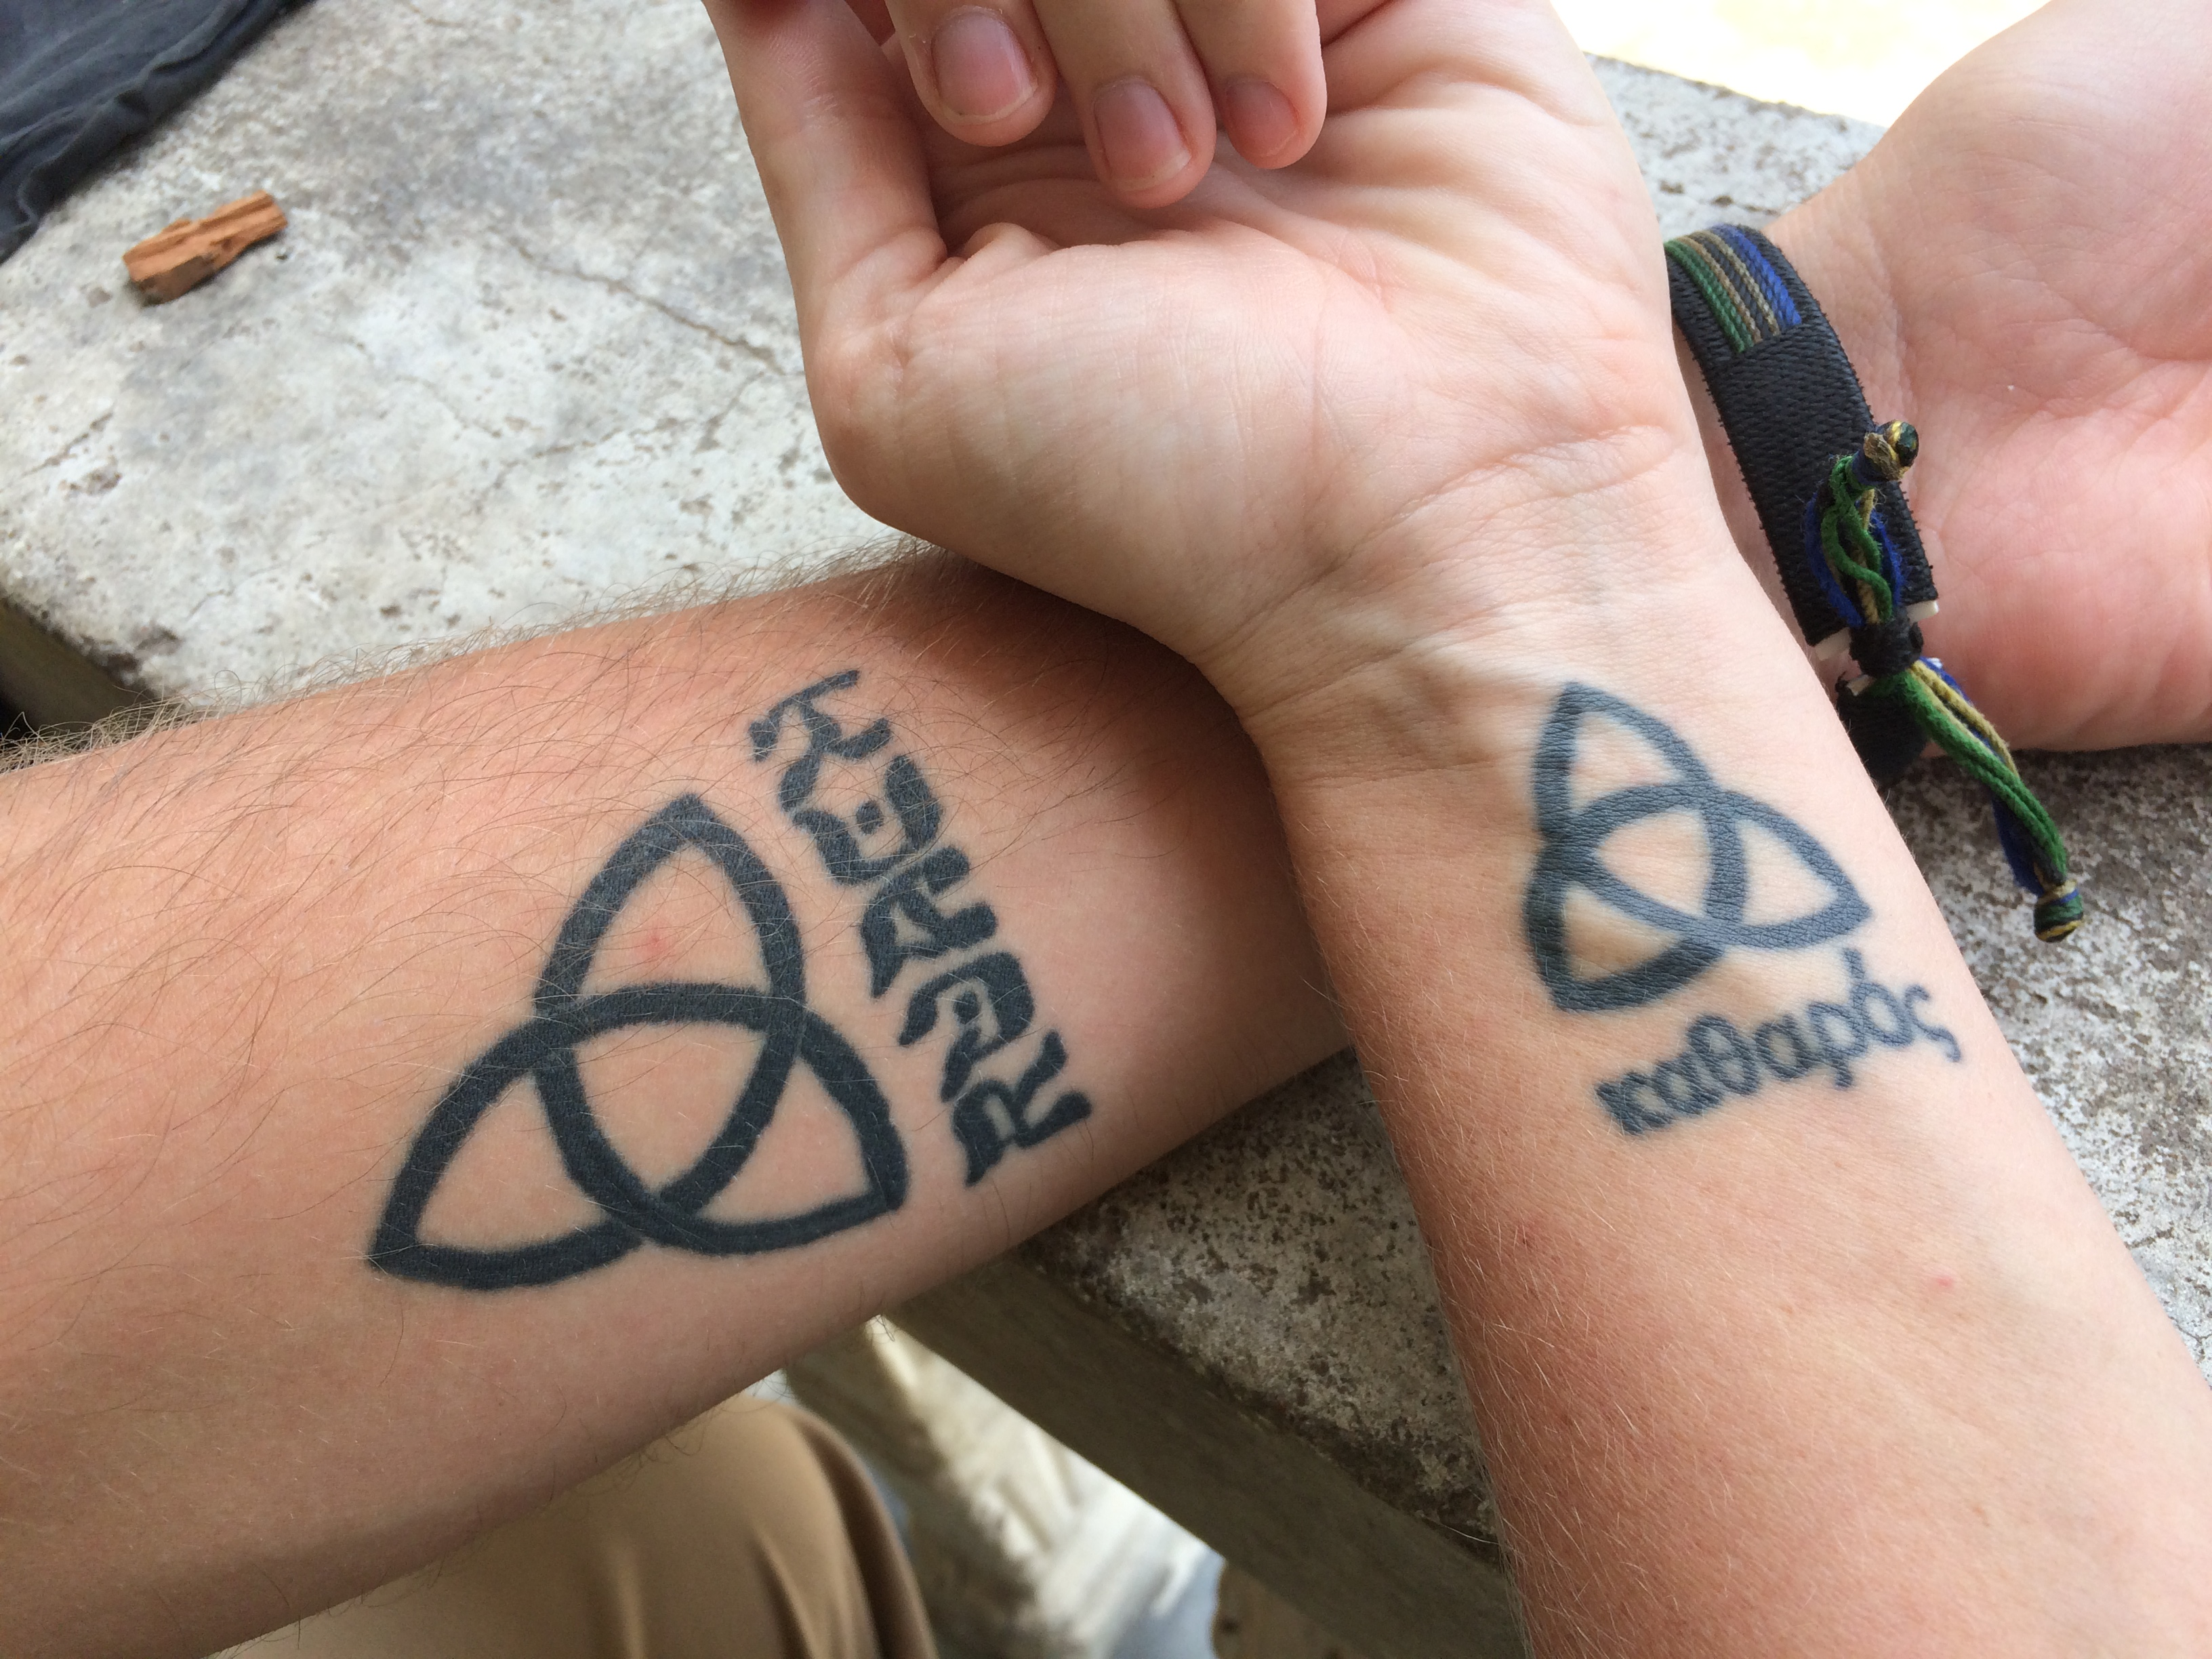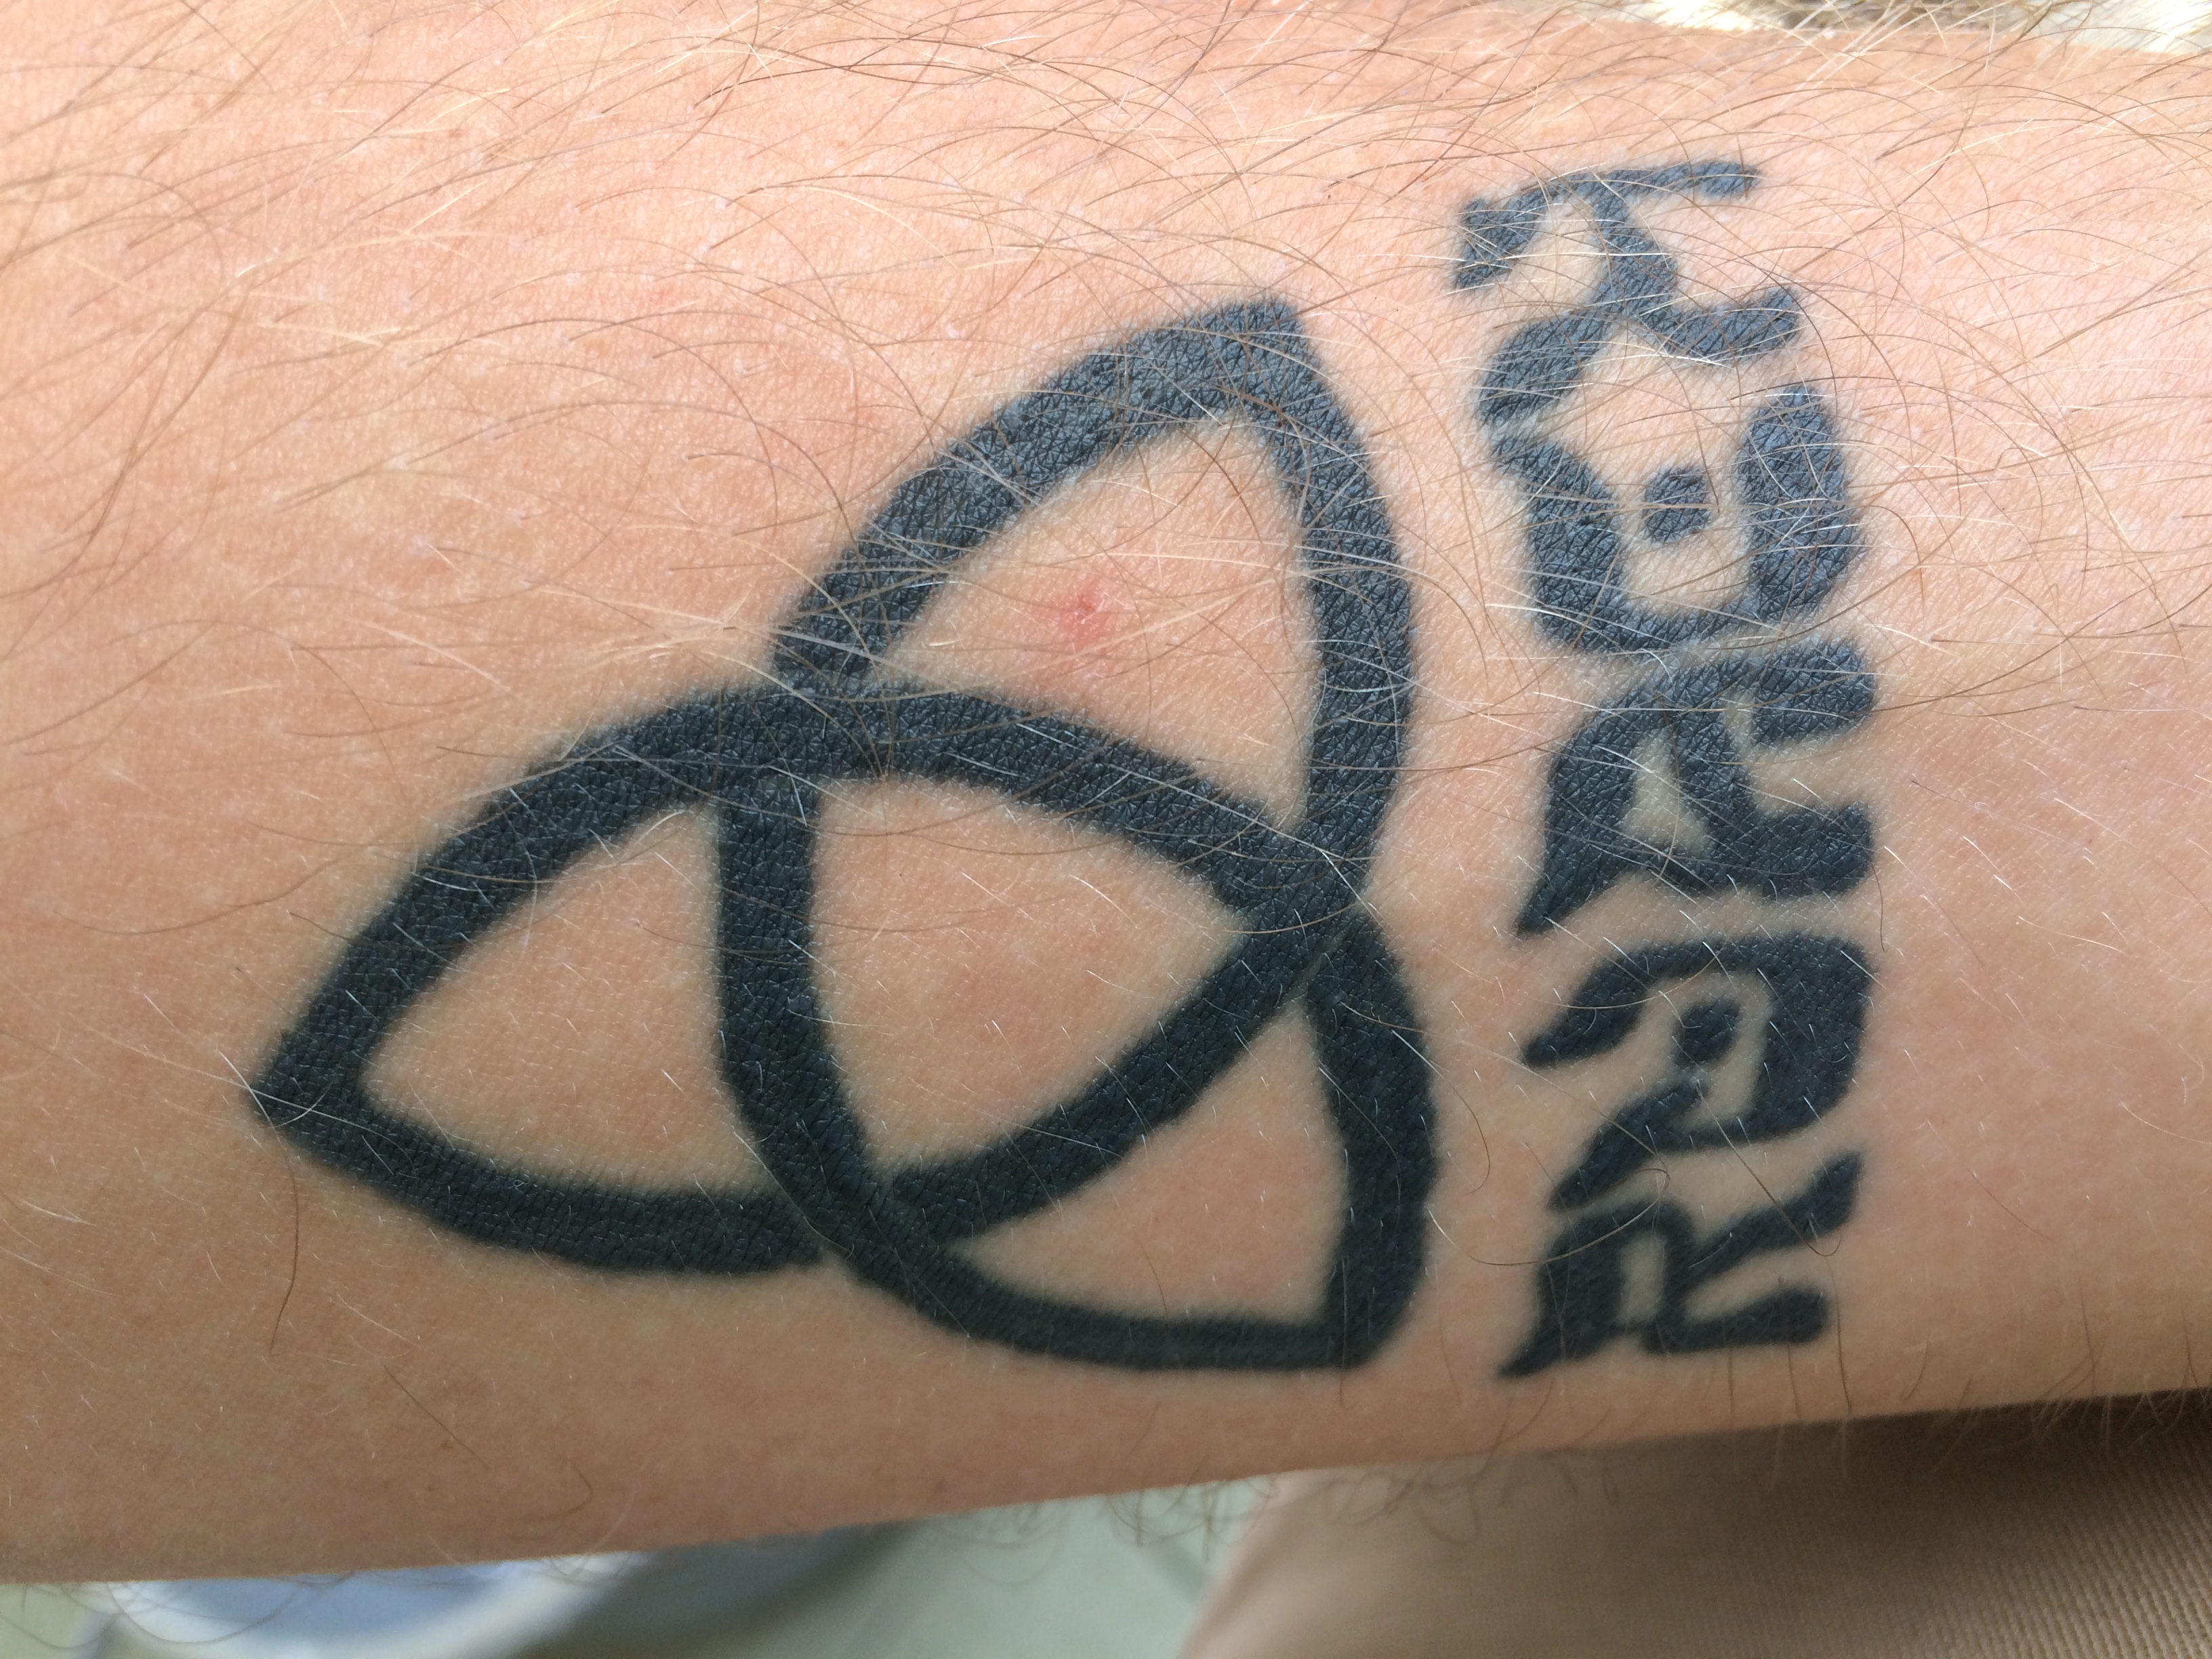
Eric and Liz Soard’s Tattoos Eric Soard’s Tattoo

Ministry of All Believers
by Rev. Dr. Cynthia A. Wilson

Scripture passages for reflection:
- Romans 12
- First Corinthians 12

In 1973, God’s call led my family to a strange land where my faith was challenged and tested, and where I would discover the primary call on my life. The place was Detroit, Michigan, not long after the Detroit riots. The church was located in the heart of the eastside where the riots had taken place. The neighborhood was threatened daily by the hostile presence of motorcycle gangs, some of which had been at the forefront of the riots of the 1970’s. Although the middle to upper middle class members of this multicultural faith community were fearful of the gang members, they continued their struggle for survival in the midst of this urban holocaust. Would the church offer the love of Christ without resentment? Would they be guilty of Spirit and truth worship in spite of their fear and anxiety? As that fear seemed to be quelled by the work of the Holy Spirit, this faith community sought to envision, re-vision and ultimately embody the call to become a Gilead—a place of healing.

After much deliberation and some resistance from the church members, a Community Development Program (CDP), housed in the church’s gymnasium became a GED site for many of the gang members. The CDP also offered a welcoming, caring, nurturing space for the gang members, many of whom worked hard to receive their high school diplomas, making them eligible for employment. Sadly, the sanctuary remained off limits for these individuals. However, after some time, the once unwelcomed visitors were invited to Sunday morning worship. It was in the context of Sunday worship that a culture of respect developed between the church and “un”-churched.

It was no surprise that many of them also knew many of the traditional hymns of the Christian faith. It was not difficult to see how the music functioned as a bridge as well as a catharsis of the spirit and soul for gang members and church members. Through prayer and song, both groups gradually developed a non-judgmental ability to speak honestly and openly, and to listen to one another. Ultimately, the leather clad biking community joined the church members in the Gilead project by becoming a self-appointed security force; wounded healers committed to the creation of a safe space for Detroit’s eastside dwellers.

Additionally, the church’s basement became a safe space for senior citizens, many of which were challenged by Alzheimer’s disease. What a joy it was to share music with men and women who were in the late evening of their lives, often oblivious to their surroundings, that is until a song was raised. Often, these seasoned citizens were unable to remember what they had eaten five minutes earlier. Yet, whenever a familiar hymn or traditional gospel song was raised, most were able to enter into the music, enthusiastically singing all verses. It would be years later that I would discover how my Detroit experience served as the beginning of my call as a minister of music in the United Methodist church.

After completing my seminary degree in 1984, for the second time I was summoned by the Holy Spirit to serve yet another local church community in transition. Polytechnic United Methodist Church, located on the campus of Texas Wesleyan University in Fort Worth, Texas, invited me to consider joining the church staff as the Director of Music. After 100 years of history in Fort Worth, I would be among the first persons of color to join the Polytechnic staff in full-time ministry. This would also be my first opportunity to provide leadership in a context radically different from my own.

Much like my Detroit experience, the demographics in neighborhoods surrounding the church were rapidly changing. The face of the Poly area was becoming predominantly Latino/a and African American. For this reason, the lead pastor along with lay leaders of the church made the important decision to take a bold step toward a similar transition: to develop a multicultural, multi-ethnic, multi-lingual staff that resembled the diversity of their neighbors. Poly UMC began to reach beyond the temple of their familiar. They purposed to extend ministry efforts beyond the comfort of their four walls, and to intentionally offer a genuine welcome to their multigenerational, multilingual, multi-ethnic neighbors. They agreed that one of the most effective ways of doing this was through music.

My time at Poly UMC provided rich opportunities for cultivating a greater sense of what it means to “teach all nations.” During my tenure there, I sought to learn and to embrace the heart songs of the Poly congregation. My own ministry was deeply enhanced by their rich congregational and choral music heritage. The Poly staff, lay leaders, and members were committed to the cultivation of the spirit of koinonia through song. Because of that commitment, through a slow, deliberate process, I was able to introduce musics from other contexts, which expanded their musical repertoire. Consequently, together we were able to establish a more welcoming atmosphere for potential new members from the community.

Over the last four decades I have been richly informed, and often even painfully transformed by the call to worship and music ministry within diverse faith communities. All too often I have asked the question: What would this world be like if we all looked, spoke, walked, talked, thought, sang, and worshipped the same? I have concluded that this would be an impoverished, monochromatic existence devoid of color, creativity, and particularity; totally antithetical to God’s idea of creation. I also have come to appreciate the similar ways in which music functions in the human body and in the worshipping Body of Christ. The intrinsic nature of music cuts through the tension of diversity, creating connections across cultures, ethnicities, denominations, and generations.
In retrospect, God has continued to strategically stretch and situate me in the Body as a responsible steward of corporate worship and music. But even more importantly, I am being held accountable for the intentional selection of worship music that inspire the full, active, and conscious participation of all worshipers so that the whole church can say “Amen!”

For further reflection:

- As you reflect on your own call to ministry, where have you seen the Holy Spirit intentionally placing you in contexts that have nurtured and helped define your understanding of God’s cultivation of your particular gifts?
- How have you responded? What new understandings and insights have come as a result of your faithful response?
- Have you ever found yourself resisting God’s call? What has kept you from heeding God’s voice, and what was the outcome of your disobedience?

Suggestions for Using Questions for Further Reflection

Our worship services are typically planned for communities instead of individuals and many times the worship service experience ends after the benediction. The heavy lifting of spiritual growth happens outside of typical Sunday morning worship experience. We are providing some questions to guide worshippers through deeper and personal reflection upon the message throughout the week.

These questions can be incorporated into the worship service’s bulletin as an insert worshippers can take home. Worshippers can be encouraged to place this insert in their Bible or devotion book to help guide daily reflection.

These questions can also be used to facilitate small group discussions during the week. Small groups can use these questions to guide group reflection on the worship service’s message. Theses questions may also encourage participants to process and share their own experiences of call.

Be encouraged to change these questions or discard them and write your own. You know your community better than we do. Meet them where they are in their call discernment and challenge them to think a little bit deeper from there.

Questions for Further Reflection

- Write in a paragraph or two about your story or developing sense of call.

- Choose a biblical passage or passages here or elsewhere and write another paragraph or two exploring how it is that God seems to be summoning transformation and/or expressing God’s faithfulness in the Bible.

- What happens when you put your autobiographical and biblical paragraphs into conversation? What are the points of convergence and divergence? Are there unexpected realizations that broaden your understanding of what discerning a call entails?

- What questions must be asked and what horizons must be considered beyond your story and the Bible to compel continual growth in understandings of call? Articulate and respond to those questions in another paragraph or two.

- Take the paragraphs written above and compose and rehearse a sermon that portrays the Holy Spirit calling us in “real life,” in the Bible, and into futures yet unknown.

- What role does the church play in determining a person’s career path? What role do you think it should play?

- Can the church help people ponder the question “What do you want to be when you grow up?” What has made a difference as you have pondered that question?

- How can you help in creating a culture of call?

- What pictures are we giving our people?

- Do you see yourself as a priest or pew sitter?

- How are we robbing people of their opportunity to live their call? What can we do this week/month/year to give them that opportunity back?

- Do you see your call as just personal or as communal?

- What type of living is your call pulling you towards?

- How can the spirit and life, hunger-for-joy-through-special-to-you-activities, given to you by God be life giving to others, spiritually and physically?

- As you reflect on your own call to ministry, where have you seen the Holy Spirit intentionally placing you in contexts that have nurtured and helped define your understanding of God’s cultivation of your particular gifts?

- How have you responded? What new understandings and insights have come as a result of your faithful response?

- Have you ever found yourself resisting God’s call? What has kept you from heeding God’s voice, and what was the outcome of your disobedience?

Invite and Empower Witnesses

A common thread running through the stories told by the authors of the Sermon Starters is that God’s call is always to serve as individual members of the whole body of Christ. Some are called to lay ministries. Some are called to the mission field. Some are called to teach, or lead God’s people to sing praise. Some are called to preach as part of an ordained order, while others are called to provide leadership and give witness as lay speakers.

Congregations must do the hard work of creating a “Culture of Call” which will enable each member to the multitude of ways God calls boys and girls, men and women, to hear and respond to God’s call on their lives. One way to create a culture of call is to invite individuals from your congregation to give witness to how God has called them, and how they have responded. Choose a variety of examples, from the woman who faithfully extends the table to the homebound, to the plumber who offers his services to the church at no charge, to the young person who helps out in the nursery or the child who is learning to play handbells. Perhaps each week you could invite one person to give a short testimony in response to the sermon in which the person briefly shares (2-3 minutes):

- Where they were when they heard the voice of God speaking, and whose voice the message came through
- How they discerned their particular response
- What they did to live out that call
- What difference it has made for their life

These testimonials may be recorded in advance through audio or video technology and played, or they may be given live. Be sure to give lots of encouragement and clear guidelines about the length of the witness well in advance to allow for preparation. Take the time to listen to the individual’s testimony and give tips where needed so they may offer their very best!

